Lab I

Brandon Trinkle

Arizona State University

Course Number: IFT 202

Professor Gary Grindle

Feb 17, 2024

Screenshot 1

Generating public and private keys.

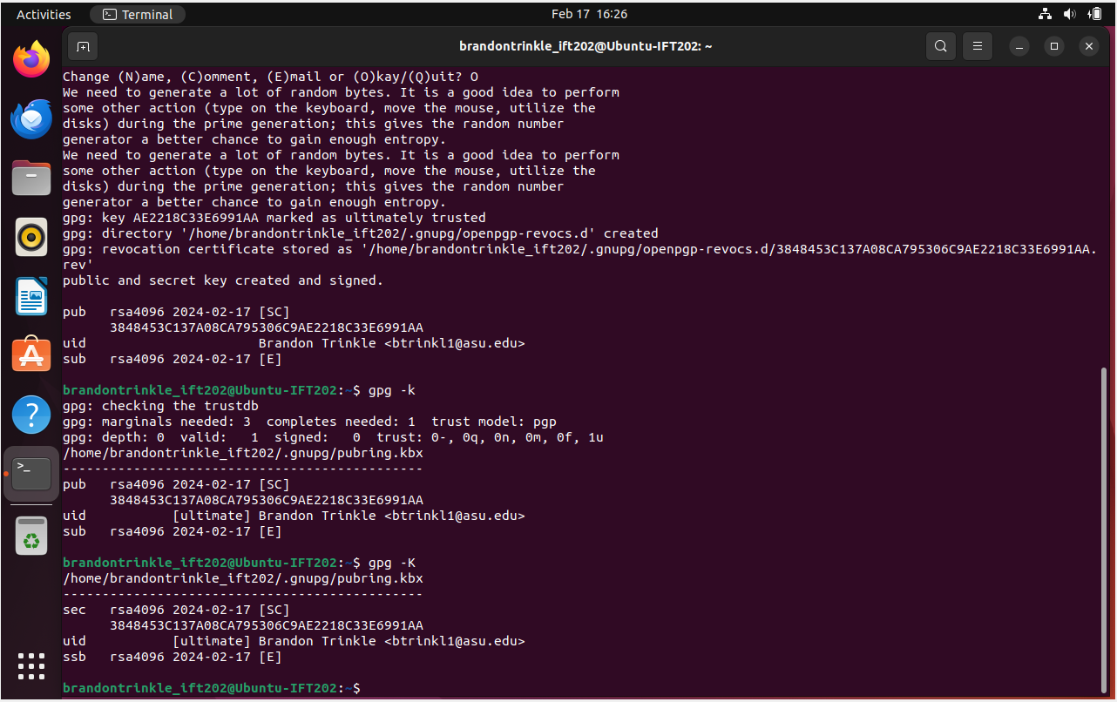

Screenshot 2

Encrypting a file using public key, then decrypt it using the private key

Screenshot 3

Export public key and display its contents.

Screenshot 4

Create a new user and import public key.

Screenshot 5

Decrypt a message from another user, created with my public key, using my private key.

Screenshot 6

Create a hash for a specific file.

